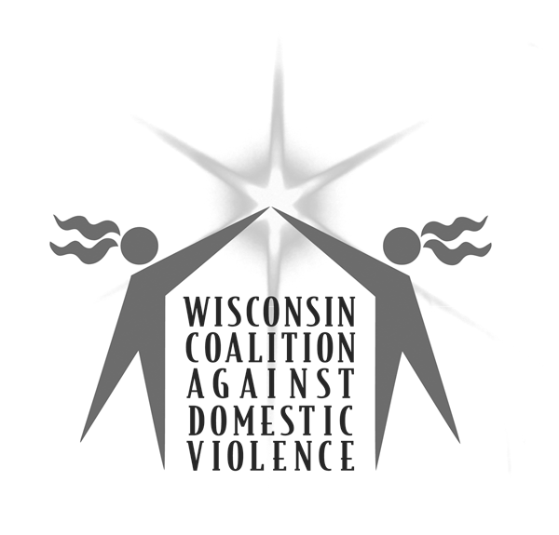
Testimony
307 South Paterson Street, Suite 1
Madison, Wisconsin 53703
Phone: (608) 255-0539 Fax: (608) 255-3560

To: Members of the Assembly Committee on Corrections and the Courts
From: Tony Gibart, Policy Coordinator, 608-255-0539 ext 310, tonyg@wcadv.org
Re: Assembly Bill 353
---------------------------------------------------------------------------------------------------------------------------
Chairperson Parisi and Members of the Committee, thank you for allowing me to submit testimony on AB 353. My name is Tony Gibart, and I represent the Wisconsin Coalition Against Domestic Violence (WCADV). WCADV is the statewide membership organization that represents domestic violence service providers and survivors. AB 353 would restore the right to vote to individuals convicted of felonies who are not incarcerated for the crime. WCADV supports AB 353.

As a victim advocacy organization, WCADV strongly believes that society should hold perpetrators accountable for the pain and harm they have caused. However, the current practice of denying un-incarcerated individuals with felony convictions the right to vote does little to accomplish this goal. Rather, the policy has far-reaching consequences; it disadvantages entire communities and creates confusion and discouragement among those who are legally entitled to vote.

Violence against women is a form of oppression that affects the lives of all women and particularly affects the lives of women who have been directly victimized. From listening to the stories of victims for over thirty years, WCADV understands that violence against women does not occur in isolation and that the existence of other forms of oppression allows violence against women to persist. Racism, poverty, homophobia, ageism and discrimination against people with disabilities are deeply connected with, and contributing factors to, the violence that victims experience. Therefore to serve victims, WCADV is compelled to speak out against these forms of oppression and advocate for a broad vision of social justice.

The current practice of denying the franchise to individuals convicted of felonies has a remarkably disproportionate impact on communities of color, especially African-American communities. Eleven percent of African-American voters cannot vote in Wisconsin, compared to only two percent of all Wisconsin voters. African-Americans make up almost 40 percent of ineligible voters, even though they represent only five percent of the voting population.

This dramatic racial disparity severely weakens African-American communities and adds to the adversities that African-American women face. African-American women are as much as 50 percent more likely to be victimized than white women and up to four times more likely to be a domestic violence homicide victim. These differentials are directly linked to higher rates of poverty and economic and political oppression. Women and victims from marginalized communities have a direct social, political and economic interest in their communities' full civic engagement. AB 353 will promote the political participation of these communities.

WCADV also supports the bill on behalf of victims who have been convicted of crimes. Some victims unfortunately find themselves involved in the criminal justice system as defendants. Victims can be charged and convicted of crimes that occurred as acts of self-defense or that were committed because of coercion from the perpetrator. In most cases, these crimes are misdemeanors, but because of confusion surrounding current law, these victims believe they are unable to vote. During a recent voter education campaign at a domestic abuse victim program, several victims stated that they thought that they did not have the right to vote because of convictions related to the abuse.

Thank you again for allowing me to submit testimony on AB 353. WCADV thanks Representative Grigsby and Senator Taylor for their leadership in restoring the right to vote. I urge the Committee to support this legislation. Thank you.

Only about 25% of felony charges are for violent crimes. Most charges (approx. 37%) are drug crimes; the great majority of these are for non-trafficking offenses. US DOJ, Bureau of Justice Statistics, Felony Defendants in Large Urban Counties, 2004,
US DOJ, Bureau of Justice Statistics, Intimate Partner Violence in the United States.

